**Embedded System and Software architecture**

The mechanical model needs to be actuated properly and thus required electrical and electronic peripherals were added to complete the automation process. The complete Embedded System is divided into various parts described in detail as subsections.

***The Brain***

The model houses a Raspberry Pi 2 and an Arduino Mega 2560 at its base, which are responsible for efficiently operating the model in Autonomous Mode.

***Raspberry Pi 2***

The Raspberry Pi 2 is a [credit card](https://en.wikipedia.org/wiki/Credit_card)–sized [single-board computer](https://en.wikipedia.org/wiki/Single-board_computer) powered by ARM Cortex A7 processor. It has the following specifications: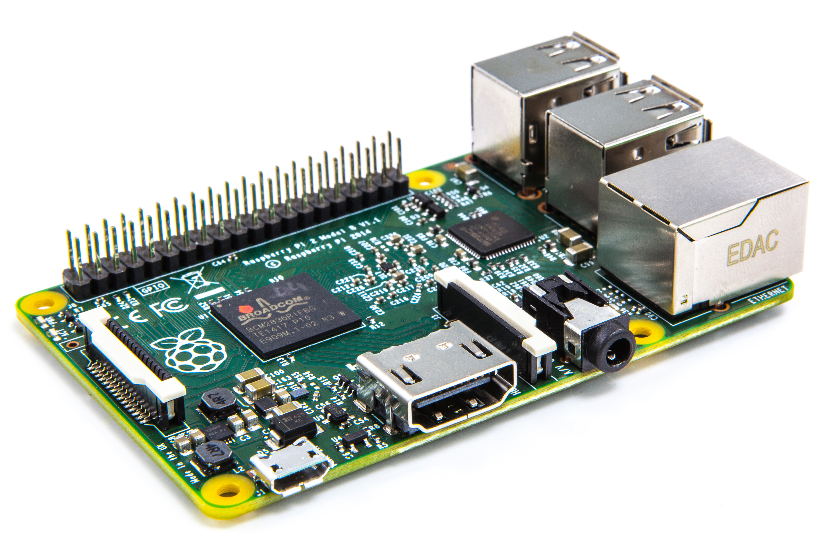

* A 900MHz quad-core 32-bit ARM Cortex-A7 CPU
* 1GB RAM
* 4 USB ports and 40 GPIO pins
* Full HDMI port
* Ethernet port
* Combined 3.5mm audio jack and composite video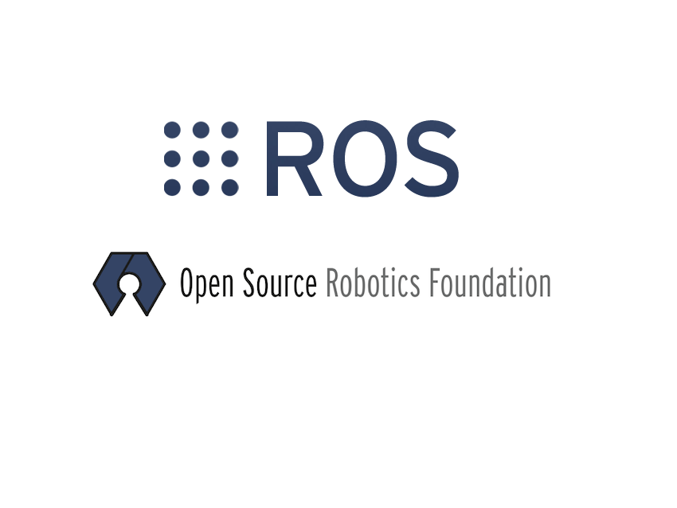
* Camera interface (CSI)
* Display interface (DSI)
* Micro SD card slot
* VideoCore IV 3D graphics core

The Pi runs Robot Operating System (ROS) framework for getting data from sensors and generating outputs for the actuators

***Arduino Mega 2560***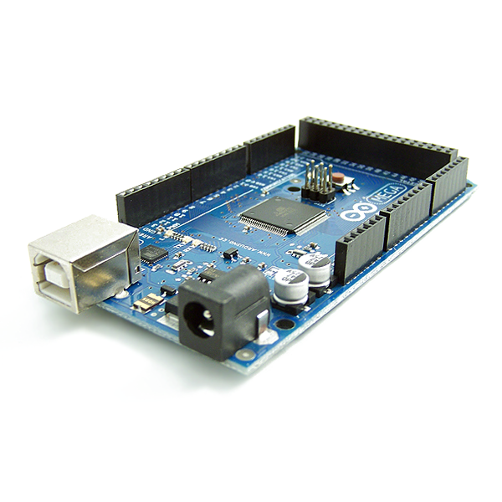

The Mega 2560 is a microcontroller board based on the [ATmega2560](http://www.atmel.com/Images/Atmel-2549-8-bit-AVR-Microcontroller-ATmega640-1280-1281-2560-2561_datasheet.pdf). It has 54 digital input/output pins (of which 15 can be used as PWM outputs), 16 analog inputs, 4 UARTs (hardware serial ports), a 16 MHz crystal oscillator, a USB connection, a power jack, an ICSP header, and a reset button.

It is used as a low-level controller in the system accomplishing the job of getting sensor data from various sensors using different protocols and outputting appropriate signals according to planner output received from the Pi to the drivers which actuate the motors.

***Drive Control System***

***Brushless DC Hub Motor and Controller***

The drive motor is a Brushless DC Hub motor operating at 24V, 350W. It is driven by a dedicated Motor Controller which has in-built control loop implemented for precise control 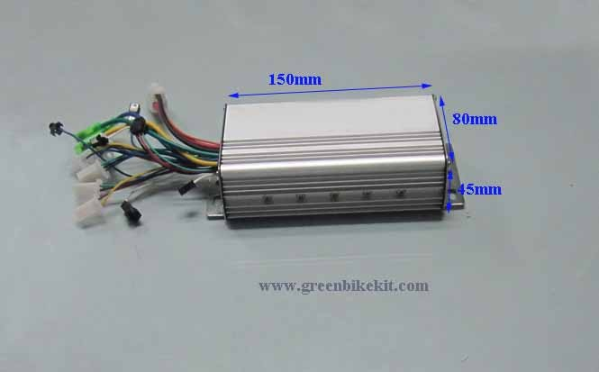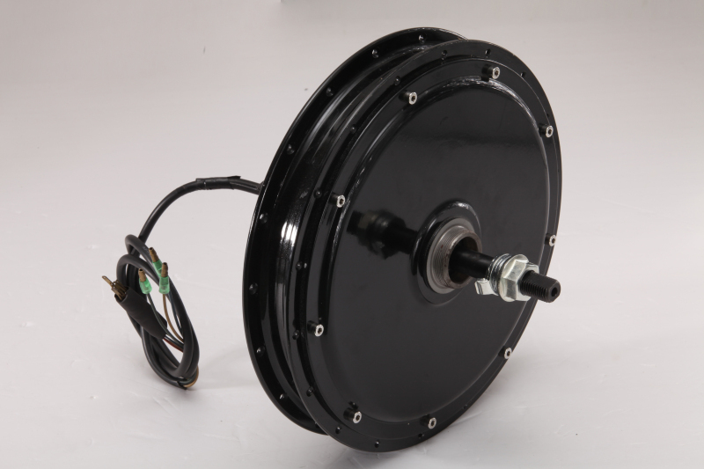over the motor speed. The controller incorporates Hall Sensor based commutation of the motor and takes an analog voltage for speed control. Direction control is not provided.

***Digital to Analog Converter (DAC)***

The analog voltage in the range 0-5V required by the motor controller is generated electronically by employing a DAC (Digital to Analog Converter) module with IC PCF8591.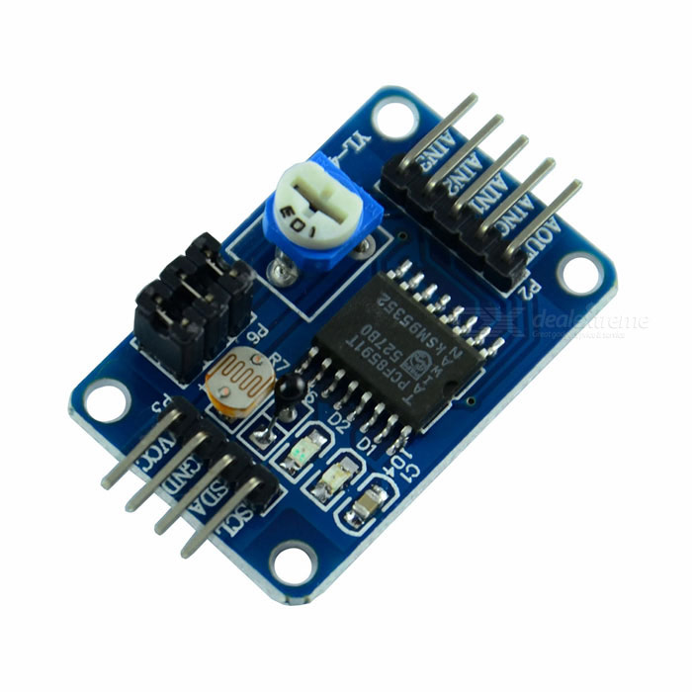

*Features:*

* Operating voltage range of 2.5V-6V
* 10-bit Digital to Analog Converter
* Works on Inter Integrated Circuit (I2C) protocol
* I2C address = 0x48

The DAC module gets data as 8-bit value from Arduino via I2C interface and the correspondingly converts it into an Analog voltage outputted at the analog output pin.

***Direction Control of Motor***

For our application forward as well as backward rotation of the BLDC motor is required and since this functionality is not provided by the motor controller, a separate circuit for switching direction of the motor is employed.

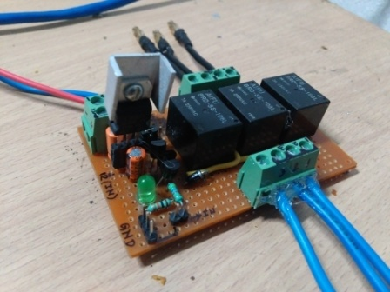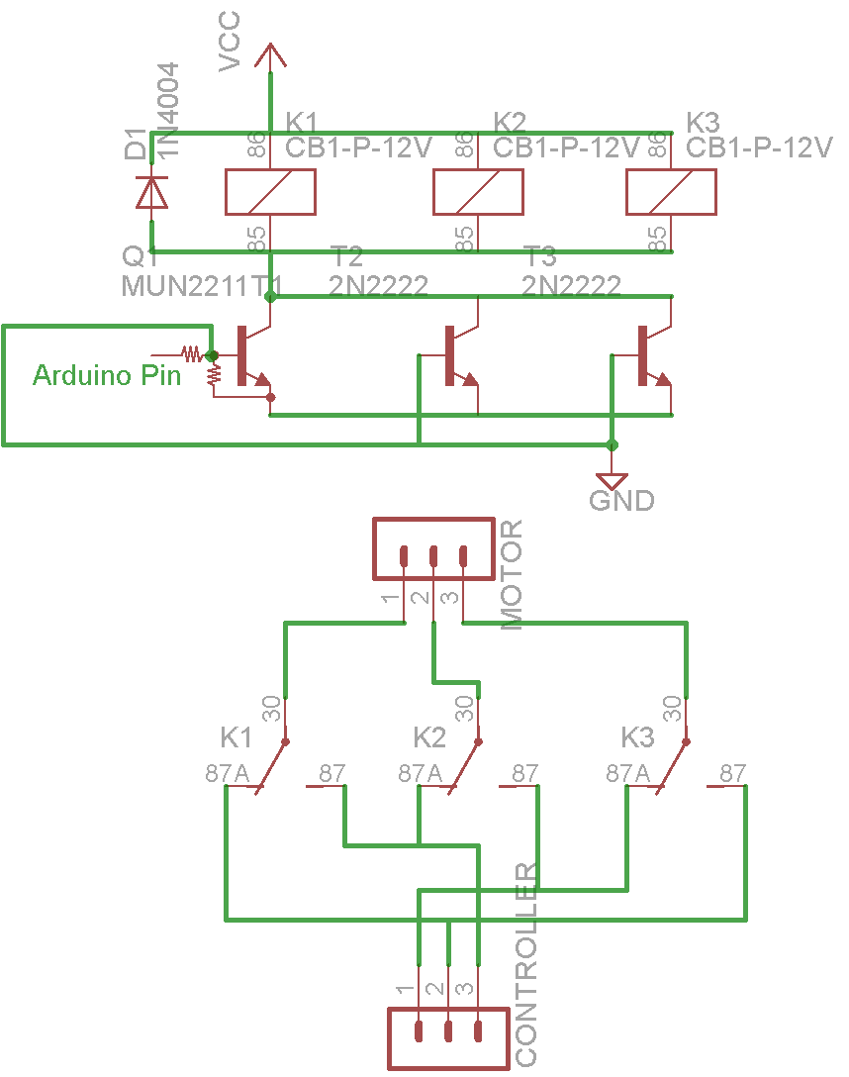The circuit works on the principle of switching the 3-motor wires in a prescribed manner between two pre-known states so as to achieve direction control. Three high-current relays with their coils controller by a BJT operating as a switch are used for the purpose of parallel switching the motor coils. The circuit schematic and the actual circuit are shown.

***Modes of Operation***

The drive supports 3 modes of operation namely:

1. *Manual Mode* - In this mode the steering is controlled manually and the drive motor is controlled by the accelerator on the handle.
2. *Interactive Mode* - In this mode Wireless Joystick Control and Bluetooth Voice Control of the model is achieved.
   1. Joystick Control - A wireless control box equipped with a joystick module is used to control the drive and steering.
   2. Bluetooth Voice Control - The model is controlled by offline voice recognition on an Android phone and communication using Bluetooth module.
3. *Autonomous Mode* - In this mode, the model locomotes autonomously at a slow speed employing Lane Detection, Path Planning and Obstacle avoidance

The switching between the modes is achieved by use of switches in the wireless control box.

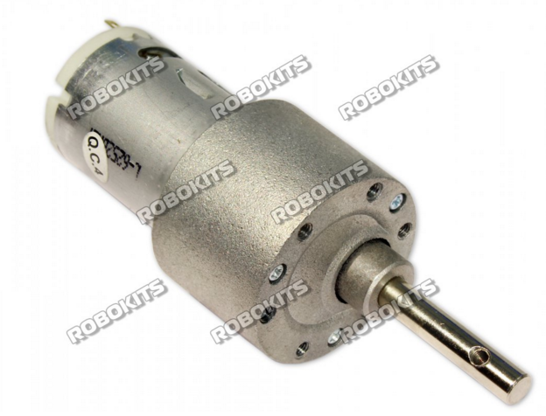

***Steer Control System***

***Steer Motor and Motor Driver***

The Steer Motor is a High-torque DC motor with the following specifications:

* 12V-18V operating voltage
* 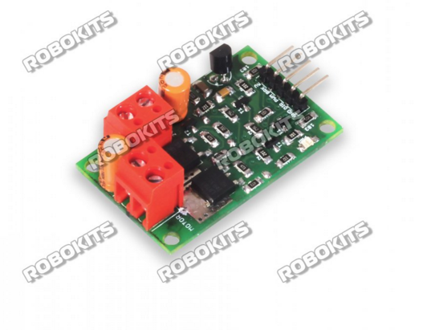Maximum torque output of 120 Kg-cm
* Maximum Load Current of 7.5A

The Motor is driven by a Dual-Half H-Bridge high current DC motor driver of following specifications:

* Compatible with motors rated 6V-18V
* Continuous output current of 20A
* Operates with PWM, BRAKE and DIR inputs. 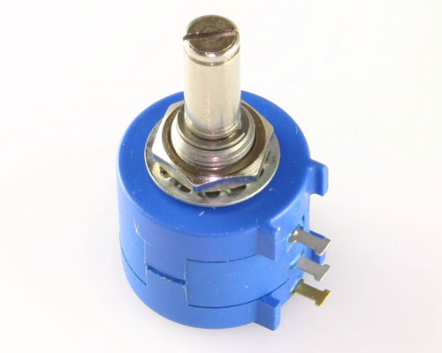

The steer motor is operated in a closed loop by taking angle feedback from a rotary potentiometer.

A PID controller is implemented in code to attain position control of the motor. The controller is tuned manually to obtain desired response.

Autonomous Mode

* Path planner dictates the handle angle using data from sonar and image processing.
* 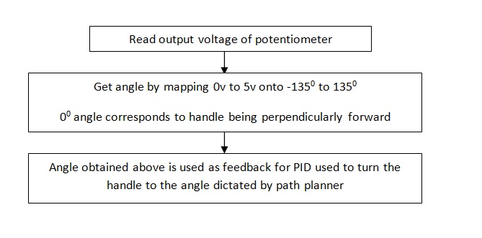A potentiometer with angle range of 2700 is attached to the handle which provides feedback to the PID controller.

Joystick Mode

* Joystick gives analog output in two axis X and Y with magnitude depending upon the extent to which it is bent.
* 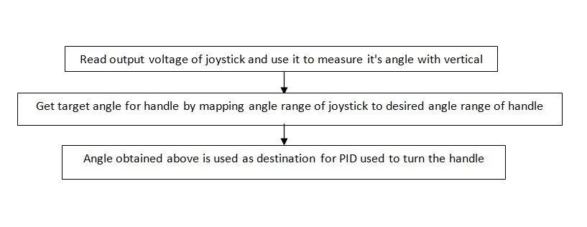The X axis is used to control drive motor and Y axis is used to control steer motor.

***Navigation System***

The navigation system incorporates sensors for detecting pose (orientation) of the model.

This data is then used as feedback to control the pose in the required manner.

The system involves the following sensors:

***Rotary Potentiometer***

It is attached to the handle shaft and gives the orientation of the handle with respect to the body. It outputs data in the form of analog signal in the range 0-5V which is processed using Analog to Digital converter (ADC).

***Inertial Measurement Unit (IMU) and Magnetometer***

A combination of IMU MPU-6050 and a magnetometer HMC5883L is used to obtain the global heading of the model.

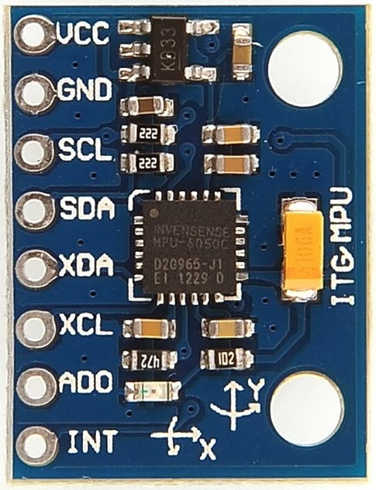

***MPU-6050***

MPU-6050 sensor contains a MEMS accelerometer and a MEMS gyro in a single chip.

* Very accurate.16-bits ADC hardware for each channel.
* Captures x, y, and z channel at the same time.
* Uses the I2C-bus to interface with the Arduino.
* I2C Address = 0x68 and 0x69

***HMC5883L***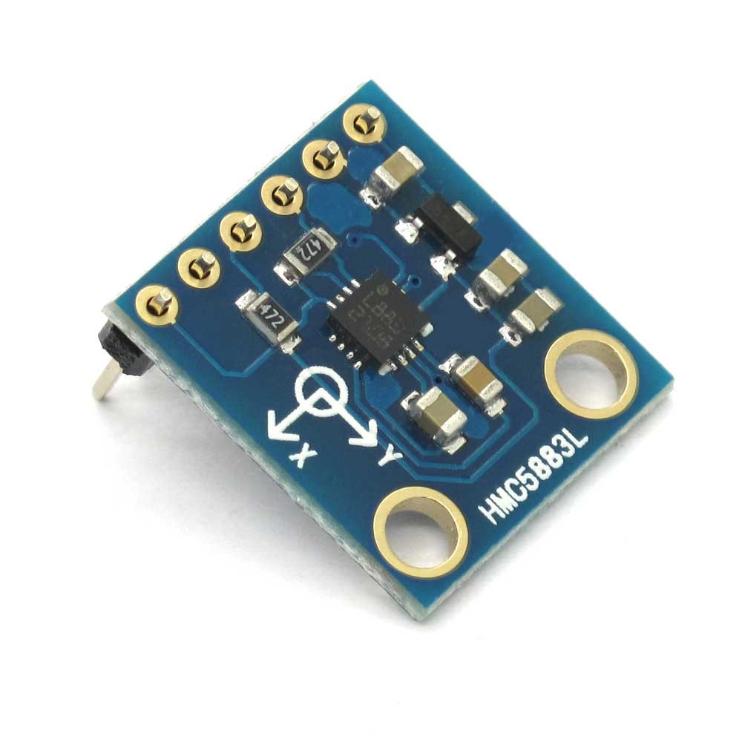

A 3-axis digital compass. Communication with the HMC5883L is simple and all done through an I2C interface.It has:

* 12-Bit ADC Coupled with Low Noise AMR Sensors Achieves 2 milli-gauss Field Resolution in ±8 Gauss Fields .
* Built-In Self Test
* Fast 160 Hz Maximum Output Rate
* I2C Address = 0x3D

The data from the IMU and Magnetometer are fused using a Complementary filter to obtain the final heading angle as described below.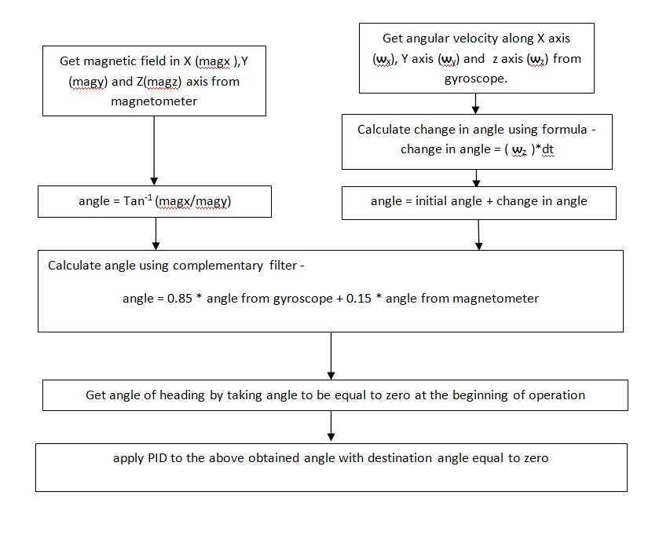

***Obstacle Detection and Avoidance***

For obstacle detection three Ultrasonic Sensors are used each pointing towards left, front and right respectively.

The time of flight of ultrasonic wave is determined and then this time information is used to calculate the distance to the obstacle.

Distance = ((Duration of high level)*(Speed of Sound))/2

***Ultrasonic Sensor HC-SR04***

* Ultrasonic sensor HC-SR04 provides distance measurement in the range 2cm-400cm.
* 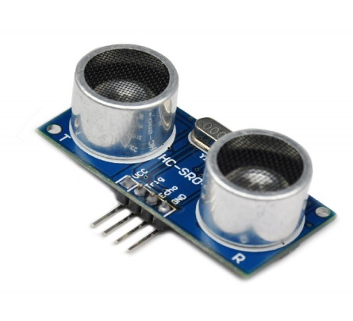 The ranging accuracy can reach to 3mm.
* The basic principle of work:
  + Using IO trigger for at least 10us high level signal,
  + The Module automatically sends eight 40 kHz and detect whether there is a pulse signal back.
  + If the signal back, through high level , time of high output IO duration is the time from sending ultrasonic to returning.

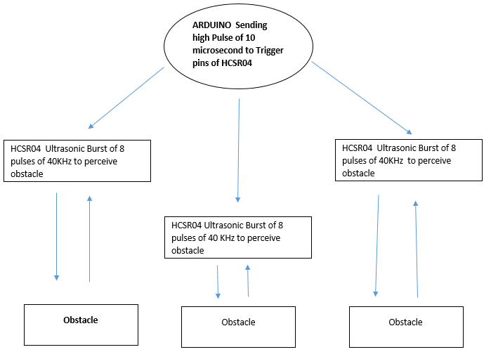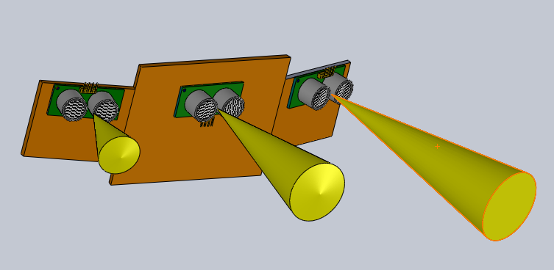

The output from the sonars is used to detect the position of the obstacle in front of the model and plan the path accordingly to avoid collision with it.

***Wireless Control Box***

The wireless control box is meant to provide the user convenience of operating the model.

The Manual mode is for people with only leg amputy in which they can use the handle accelerator to control the model at their will.

The Interactive mode features a Joystick Control mode for elderly people who are to be restricted from stretching muscles. The handy wireless control box provides a convenient method for them to control the model fully at the tip of their fingers.

The control box employs an Arduino Nano as its brain. It involves sensors and modules as listed below:

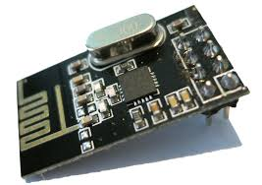

***Nordic NRF24L01+***

The Nordic nRF24L01+ integrates a complete 2.4GHz RF transceiver, RF synthesizer, and baseband logic including the Enhanced ShockBurst™ hardware protocol accelerator supporting a high-speed SPI interface for the application controller. The low-power short-range (50-200 feet or so) transceiver is available on a board with Arduino interface and built-in Antenna.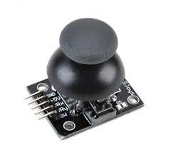

***Joystick Module***

The 2-Axis Joystick provides a simple and convenient way to add X-Y control to a project. A potentiometer attached to each axis provides proportional feedback of the up/down and left/right positions. The joystick is spring-loaded, so that it always returns to its centred position when you release it.

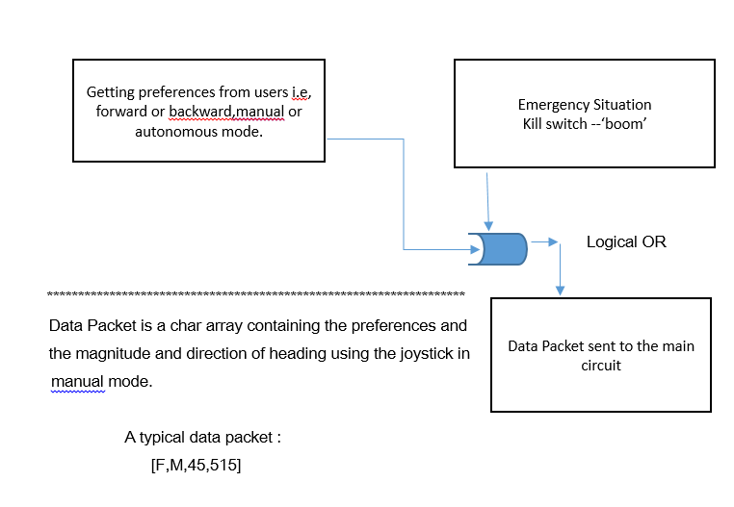The circuit schematic for the control box and the workflow block diagram is as shown below: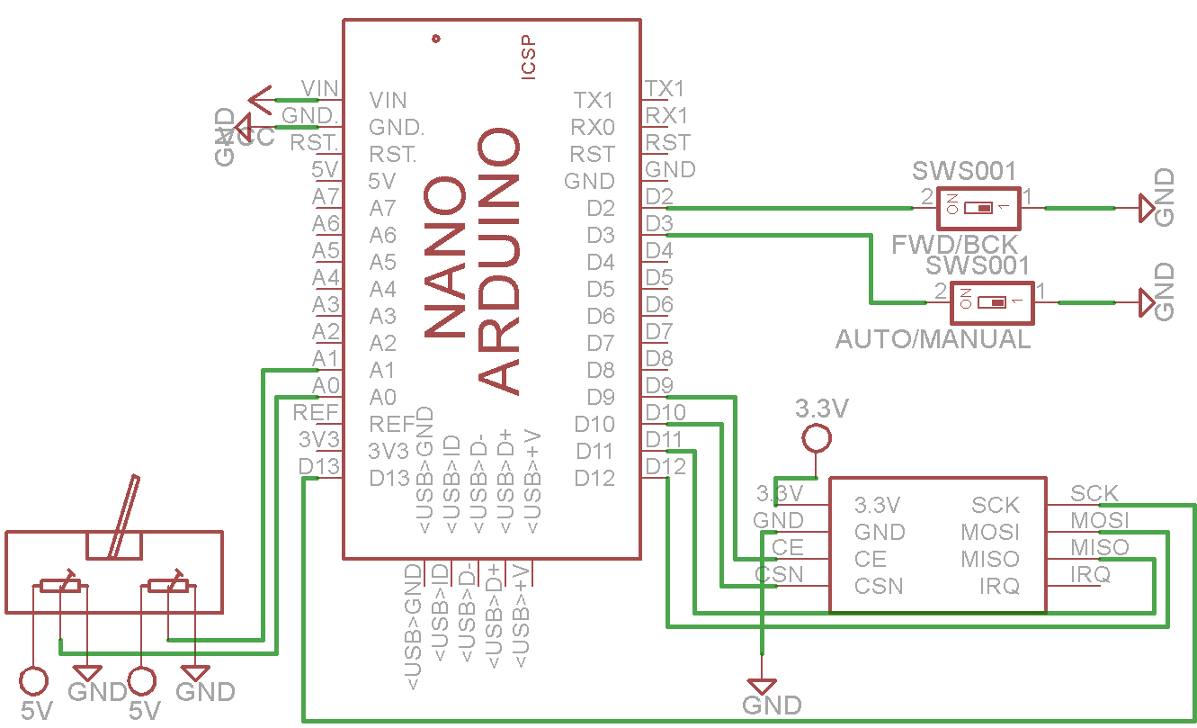

***Power Management***

The model is powered by two Lithium Polymer batteries.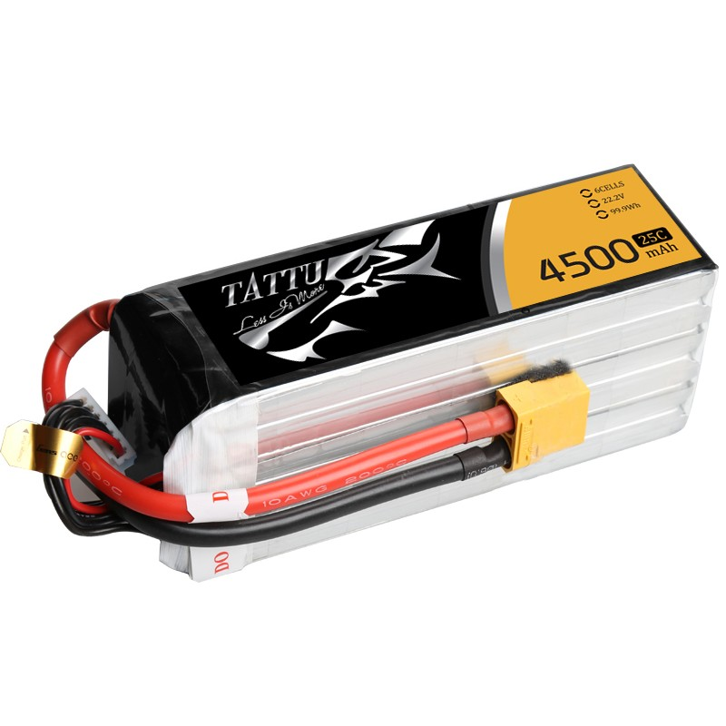

1. *22.2V, 4500mAh, 25C*
2. *11.1V, 3700mAh, 25C*

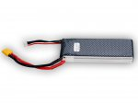

The power consumption analysis of the complete system is depicted in the table below.

|  |  |  |  |  |
| --- | --- | --- | --- | --- |
| **Component** | **Model No.** | **Current Rating** | **Operating voltage** | **Power** |
| 3-Sonars | HC-SR04 | 15mA | 5V | 75x3 = 225mW |
| Raspberry Pi 2 | - | 350mA | 5V | 1500mW |
| IMU | MPU6050 | 4mA | 5V | 20mW |
| DAC | PCF8591 | 20mA | 5V | 100mW |
| BLDC Motor | - | 10A | 24V | 240W |
| Steer motor | - | 7.5A | 12V | 90W |
| Brake Motor | - | 300mA | 12V | 3.6W |
| Arduino(IDLE) | - | 100mA | 5V | 500 mW |
| Wireless Receiver | NRF24L01+ | 15mA | 5V | 75 mW |

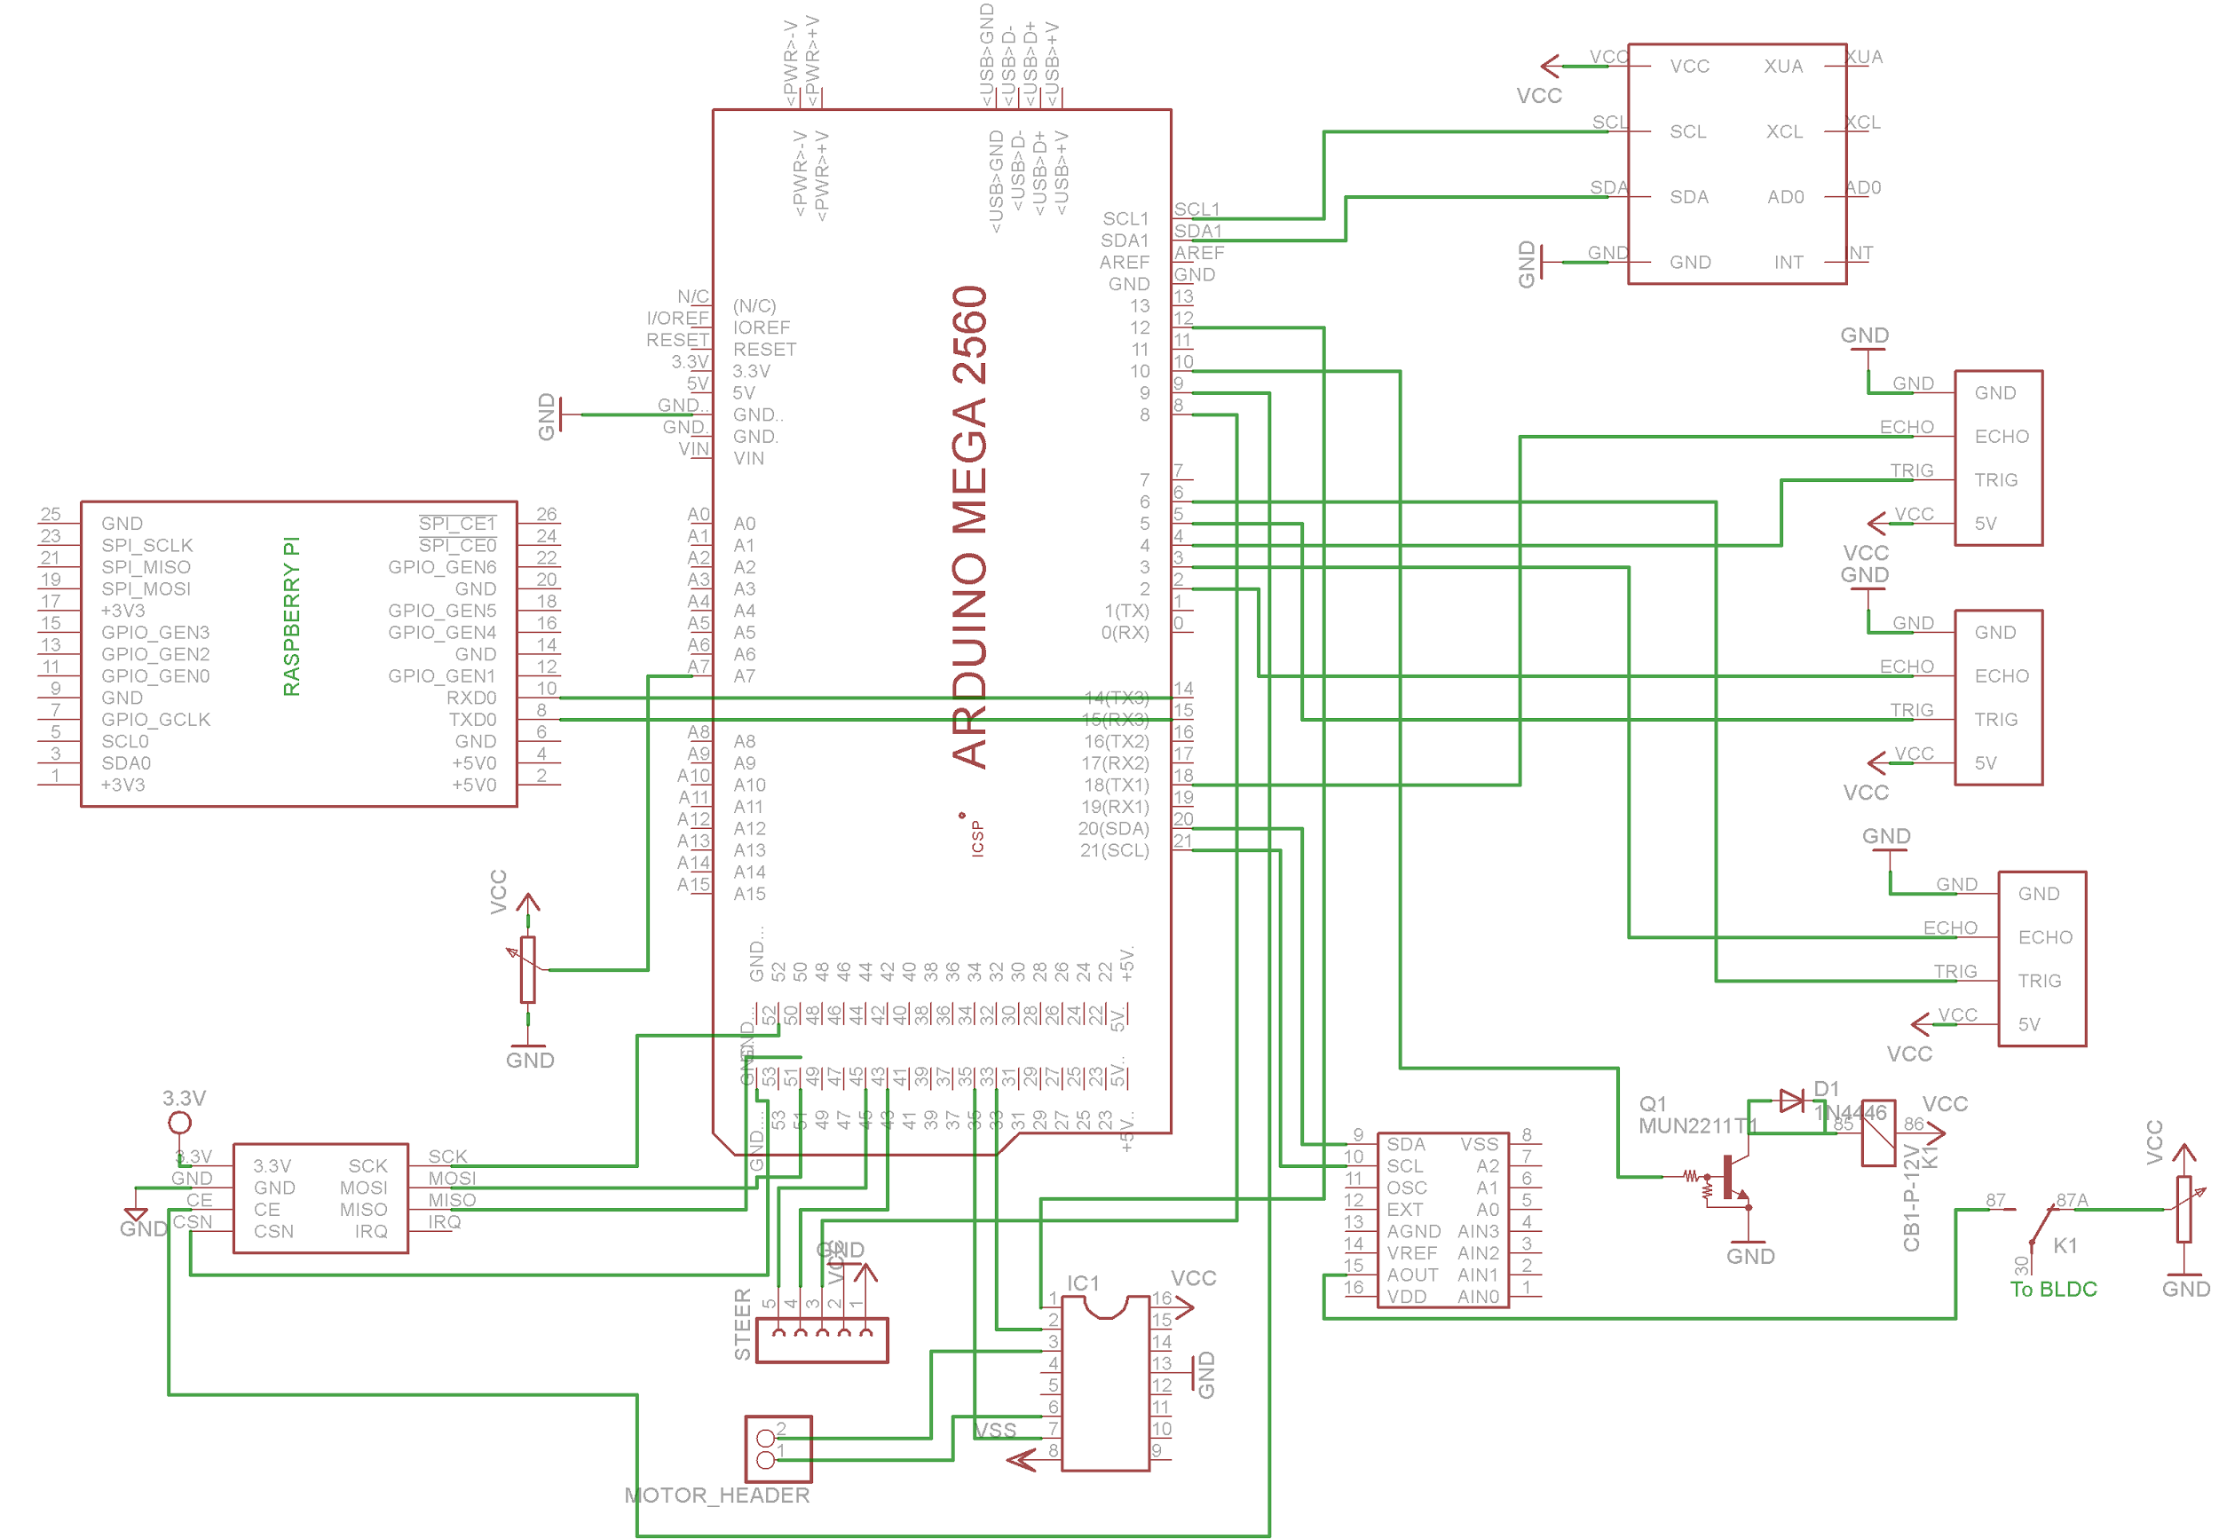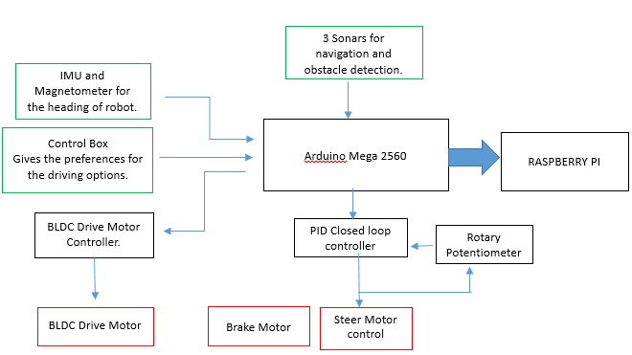***Complete Embedded Architecture and Circuit Schematic***

***Image Processing using OpenCV and ROS on Raspberry Pi***

For individuals suffering from disabilities, driverless vehicles could provide a level of freedom that was previously unobtainable. While previously people living with a disability may have had to rely on carers, family and public transport to get out and about on a daily basis, self-driving cars open up a new wealth of possibilities. An autonomous vehicle could allow a user to travel further to work, explore areas which aren't served by public transport and basically organize their own lives, whereas in the past this might not have been possible.

Since Raspberry Pi is capable of computer vision based control, the navigation of the model can be greatly aided by the application of certain image processing algorithms. The following were implemented using computer vision with ROS on the Pi.

***Lane Detection and Tracking***

The aim was to achieve the objective of lane detection and navigation using real time image processing and perspective transformation.

The problem was approached stepwise as following:

1. *Filter noise from image*

Since the input image contains a lot of noise, it was necessary to pre-process the image using noise filters. Gaussian and median filter gave good results. Other common approaches like erosion and dilution slowed processing without any significant improvements.

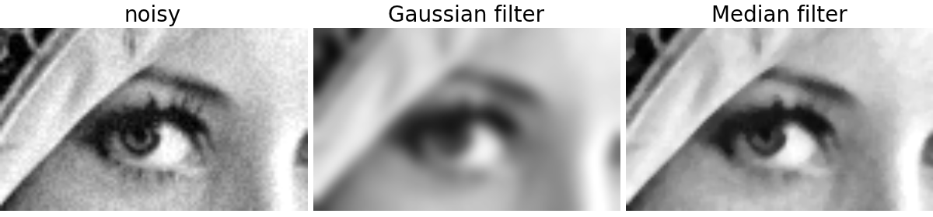

1. *Run Canny operator on the image:*

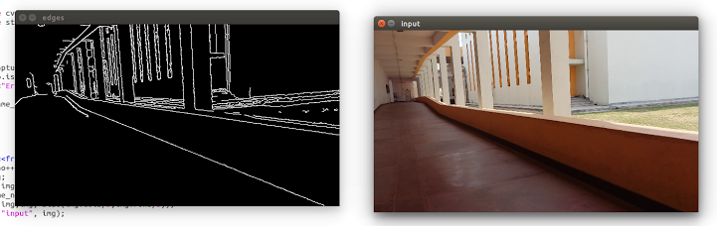After filtering out noise, we run the canny edge detector. The detector computes intensity gradients for the image and compresses non-maximum edges. A double threshold is applied to find potential edges.

1. *Hough line transformation and identifying lanes:*

Hough line transform is used identify lines by a voting procedure. The algorithm uses a two-dimensional array, called an accumulator, to detect the existence of a line described by:.

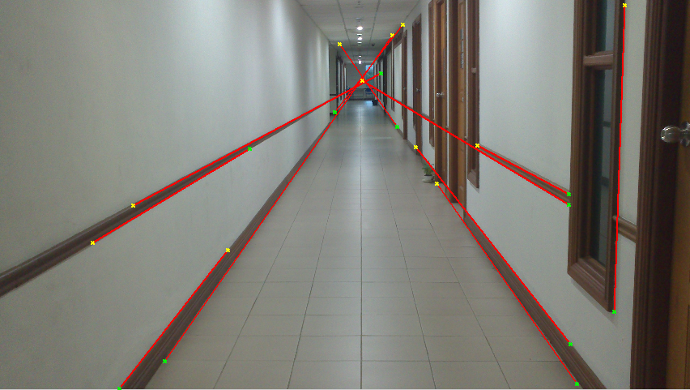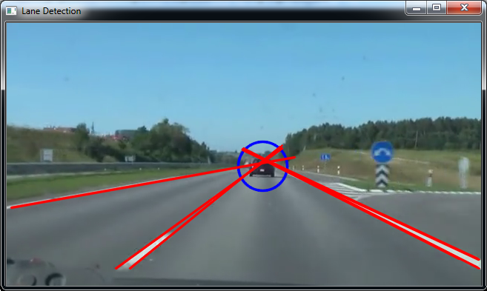 Lines with large enough consensus set are considered for further processing. The filter out pillars and other non-lane lines, the criterion used is: The right lane always intersects the lower-right boundary of the image and vice-versa for left lanes.

1. *Merging similar lines and Inverse perspective transformation:*

Generally there are a lot of lines corresponding to a single lane. An average line is computed for each lane using several restrictions on angle and intercepts. After this we have two basic lines corresponding to those lanes.

Now to localize our position in the lane we apply inverse perspective transformation. This gives us the birds eye view of the road so that we are able to locate the birds eye distance from both the lanes. This helps in building the mapping and navigation system.

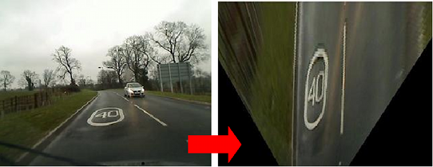

***Obstacle Detection***

Attempt was made to extract features, assign descriptor vectors and match them with standard templates to detect obstacles. Accurate descriptors like SIFT were too slow for real time implementation and faster versions like Surf and Orb weren’t reliable enough.

OpenCV provides a machine learning framework for training and using classifiers (Haar Cascade Classifier) for object identification. The classifier was used and the algorithm was trained using multiple images of standard obstacles. But the results weren’t accurate enough so as to be implemented on hardware.

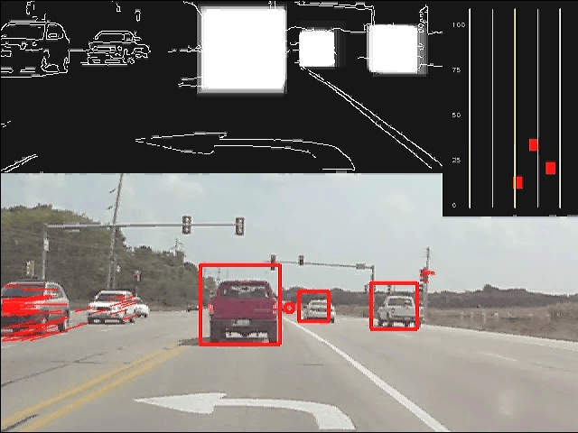

***Android Application for Offline Bluetooth Voice Control***

The app connects with Bluetooth adapter using RFCOMM protocol and provides commands using voice recognition.

The voice recognition is implemented offline for a pre-defined dictionary of words which determines the closest match between the detected voice signal and the stored words in the dictionary. The recognized word is then sent to the Embedded System on the model via Bluetooth. Offline recognition significantly improves the voice recognition speed.

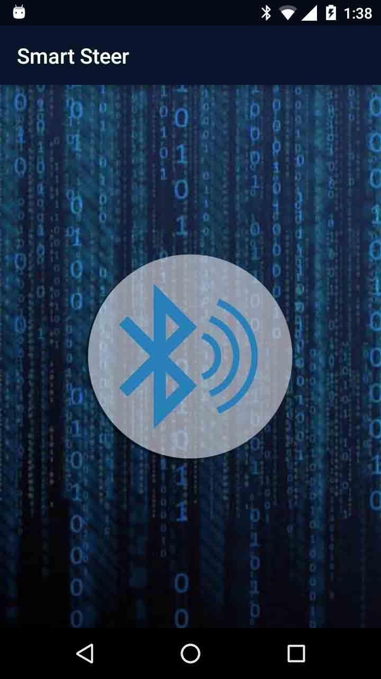User Interface of the app is as follows:

User is notified using Toast (a small popup) and a notification sound for every command sent via Bluetooth. App also runs in background to support voice recognition even when user is not using the app or the device’s screen is off.